Oklahoma Alliance for Geographic Education
South Asia:
Relating Physical Systems to Population Density

Teresa Potter
Moore Public Schools
teresapotter@mooreschools.com
OKAGE Teacher Consultant and Planning Team

WGA II
October 19, 2011

All materials may be reproduced for the classroom and presentations only when proper acknowledgement is given to the author and the Oklahoma Alliance for Geographic Education.
SOUTH ASIA: RELATING PHYSICAL SYSTEMS TO POPULATION DENSITY
Teresa Potter, OKAGE TC
Fisher Elementary
Moore Public Schools
OKC, OK 73170
teresapotter@mooreschools.com

Grade Level: 6th-12th Grade

Purpose/Overview:
The goal of this lesson is to have students to see the relationships between physical systems and population density. They will use map skills to see relationships in India, Afghanistan and Pakistan.

National Geography Standards from Geography for Life

Essential Element III. Physical Systems
Standard 7. The physical processes that shape the patterns of Earth’s surface
Standard 8. The characteristics and spatial distributuion of ecosystems on Earth’s surface

Essential Element IV. HUMAN SYSTEMS
Standard 9. The characteristics, distribution, and migration of human populations on Earth’s surface.
Standard 11. The patterns and networks of economic interdependence on Earth's surface.
Standard 12. The processes, patterns, and functions of human settlement

Essential Element VI. THE USES OF GEOGRAPHY
Standard 17. How to apply geography to interpret the past.
Standard 18. How to apply geography to interpret the present and plan for the future.

Oklahoma Priority Academic Student Skills (PASS)
Grade 7 World Geography
Standard 4: The students will evaluate the human systems of the world.
5. Evaluate issues of population location, growth, and change, including density, settlement patterns, migration, and availability of resources.

Common Core State Standards for Literacy in History/Social Studies
CC.6-8.R.H.7: Integration of Knowledge and Ideas: Integrate visual information (e.g., in charts, graphs, photographs, videos, or maps) with other information in print and digital texts.

CC.6-8.W.HST.1.b: Text Types and Purposes: Support claim(s) with logical reasoning and relevant, accurate data and evidence that demonstrate an understanding of the topic or text, using credible sources.
CC.6-8.W.HST. 1.e: Provide a concluding statement or section that follows from and supports the argument presented.

Geographic Themes: Location, Place & Human Systems

Objectives:
The students will…
- Use interactive maps on the National Geographic website
- Analyze surface elevation on a map of Southeast Asia focusing on India and Pakistan
- Analyze population density on a map of Southeast Asia focusing on India and Pakistan
- See relationships between physical systems and population density
- Make inferences between physical systems and population density
The students will know…
- How to use MapMaker interactive on the National Geographic website
- The relationship between physical systems and population density in South Asia
The students will be able to…
- interpret and analyze information
- interpret and analyze maps
- summarize what they have learned

Materials:
- Handouts
Maps of India and Pakistan-
Click on the country and print.
http://education.nationalgeographic.com/education/mapping/interactive-map/
“South Asia Geography”
“Analyzing and Interpreting Maps”
- Map pencils
- Computers
- Smart Board or equivalent

Time Frame: 1-2 class periods

Procedures:
Anticipatory Set
Ask the students the following questions:
- How dense is the population where you live?
- If you drew an imaginary five-mile square around your house and counted the number of people who lived within the square, would there be many residents, or few?
- Why is the population of California much greater than the population of Alaska?
Tell them that population density is the average number of persons living within a certain area, and that you can find out how densely populated a place is by reading a population map. We are going to learn how to read a population map and an elevation map. We will draw conclusions about why people live where they live.
Teach
- Pass out the maps of India and Pakistan. Tell students that they are going to focus on Pakistan and India. Have them trace around those countries with a black map pencil.
- Have students locate and label land and water features mentioned in the “South Asia Geography” handout on their maps.
- Using a Smart Board, demonstrate how to use MapMaker Interactive at www.education.nationalgeographic.com

Assessment
- Complete the handout, “Analyzing and Interpreting Maps.”

Assessment Options:
All maps and handouts will be assessed.

Extension and Enrichment:
Students can…
    - Use the same teaching methods to see the relationship between physical systems and population in other countries.
    - Include China in the comparison
    - Create a physical map or population density map for another country.
    - Use the website to create a product map.

Simplification:
Students can be partnered and get help with worksheets. They can look at one country instead of two.

Connections:
National standards in writing, social studies and art are addressed in this lesson.

Resources:
Websites
http://education.nationalgeographic.com

http://geography.howstuffworks.com
http://education.nationalgeographic.com/education/mapping/interactive-map/

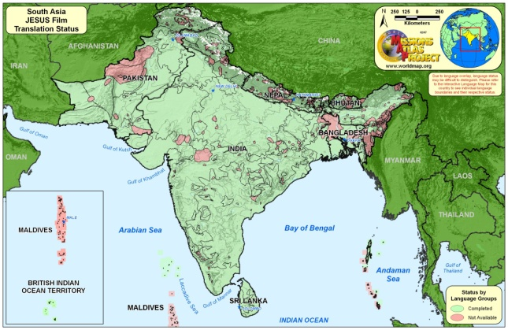
South Asia Geography

Pakistan
http://worldmap.org/maps/prepared/regional/south%20asia/South_ASIA_jfilm.jpg
Land
Pakistan consists largely of high mountains, plateaus, and lowland plains. Its mountainous section, occupying about half of the land, lies west of the Indus River. Beginning near the Arabian Sea, ranges extend northeastward and increase in height toward the Himalayas. Peaks rise more than 11,000 feet (3,350 m) above sea level in the Sulaiman and other central ranges. In the majestic Hindu Kush range of the far north stands glacier-capped Tirich Mir. Rising to a height of 25,230 feet (7,690 m), it is the highest peak in Pakistan. Breaching the ranges are many passes, most notable of which is Khyber Pass. The largest plateau area lies in Baluchistan, in the southwest.
Lowlands prevail east of the Indus River. In the Punjab region, in the northeast, fertile alluvial plains parallel the rivers. There is also some steppe and arid land, notably the That Desert. Most of the Sind region in southeastern Pakistan fringes the Thar, or Great Indian, Desert—a virtual wasteland except in areas where irrigation water is available.
Water
Pakistan is drained primarily by the Indus River and such principal tributaries as the Jhelum, Chenab, Ravi, and Sutlej rivers. The Indus system is extremely important to both India and Pakistan. In many areas, irrigation water supplied by the rivers is the only means of sustaining life. The Indus Waters Treaty of 1960, negotiated through the World Bank, allocates the waters of the Indus, Jhelum, and Chenab to Pakistan and the waters of the Ravi and Sutlej to India. Hydroelectric power, flood control, and irrigation water are provided by several large dams, chief of which are the Tarbela, on the Indus, and the Mangla, on the Jhelum. By volume, the Tarbela dam is the world's largest.
India
Land
India has three distinct physical regions: the Himalayas, the Ganges Plain, and the Deccan Plateau.
The Himalayas extend along the nation's northern border, forming a high mountain wall, 100 to 150 miles (160 to 240 km) wide, that separates the Indian subcontinent from Asia's interior. The region consists of a complex system of mountain ranges that divide into three roughly parallel chains: the Siwalik Hills, Lesser Himalayas, and Great Himalayas. Several other ranges strike off from the Himalayas along the Burmese border.
In the towering, snow-covered ranges of the Great Himalayas are many of the world's highest peaks. Though the highest summits are in Nepal and China, numerous peaks in India exceed 20,000 feet (6,100 m) above sea level. Kanchenjunga, the nation's highest, reaches 28,209 feet (8,598 m). Heights of 5,000 to 15,000 feet (1,500 to 4,500 m) mark the Middle Himalayas, which, in turn, give way to low foothills of less than 4,000 feet (1,200 m) in the Outer Himalayas.
Huge glaciers and snowfields on the flanks of the higher ranges feed rivers that flow southward through deep gorges and narrow, steep-sided valleys to the Ganges Plain.
The Ganges Plain is a broad, alluvial lowland, 100 to 300 miles (160 to 480 km) wide, spanning the country south of the Himalayas. It consists mainly of the fertile basin of the Ganges River. The land is generally flat, with a slight downward slope toward the east. Much of India's farmland and many of its largest cities are on the plain, one of the most densely settled areas on earth. Only the Thar (Great Indian) Desert, an almost barren area in the west, is sparsely populated and little used.
The Deccan Plateau, often called simply the Deccan, occupies the peninsula south of the Ganges Plain. It is roughly triangular in shape and consists of a vast tableland broken by river valleys, with areas of rolling hills. The land slopes gently downward toward the east.
Fringing the Deccan on the north are the Chota Nagpur Plateau and a maze of low mountains, including the Vindhya and Satpura ranges, in the west. Elsewhere the plateau is bordered by escarpments, known as ghats. The Western Ghats, 3,000 to 5,000 feet (900 to 1,500 m) high, form a sheer wall that drops abruptly to a narrow coastal plain along the Arabian Sea. The Eastern Ghats, in contrast, consist of low, disconnected ranges that slope gently toward a broader coastal plain along the Bay of Bengal. At the southern end of the peninsula, connecting the Eastern and Western Ghats, are the Nilgiri, Anaimalai, and Cardamom hills.
Water
India's principal river is the Ganges. It flows from the western Himalayas to the Bay of Bengal—a distance of more than 1,500 miles (2,400 km). Together with such tributaries as the Yamuna, Son, Ghaghara, and Gandak, the Ganges drains most of the mountains and the plains and part of the Deccan. In the northeast the Brahmaputra River follows a tortuous course through the Assam Valley from China and merges with the Ganges to form a vast delta, lying partly in India and partly in Bangladesh. The Ravi and Sutlej rivers, part of the Indus system, flow across northern India to Pakistan.
The Deccan is drained primarily by the eastward-flowing Mahanadi, Godavari, Krishna, and Cauvery rivers. They form large, fertile deltas at their mouths on the Bay of Bengal. The Narmada and Tapti are the only sizable rivers flowing to the Arabian Sea.
India's rivers are used extensively for irrigation; they are also used for hydroelectric power and navigation. Of particular importance is the Indus River system, which provides water for the dry Punjab region of India and Pakistan. The Indus Waters Treaty of 1960 allocates the waters of the Ravi and Sutlej to India and the waters of the Indus and its other major tributaries to Pakistan. Bhakra Dam, on the Sutlej River, is the largest of many dams in India and one of the highest dams in the world.

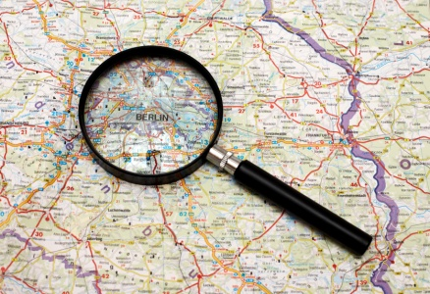
Analyzing and Interpreting Maps
Name ___________________________________
Learn the Skill
To read and interpret a map, follow these steps.
- Read the title and look at the map to get a general idea of what it shows. The title and map key will tell you what the topic of the map is.
- Read and understand how the map uses symbols and colors. Each variation in color represents something different on the map as explained in the map key.
- Use the key to interpret the map. Identify areas of various elevations and densities on the maps.
- Draw conclusions about what the maps show. The geography of a place affects its population density. Draw on this information, plus what you read on the map, to make conclusions about why particular areas have a higher or lower population density.
Practice the Skill
Use the steps above to read and interpret the surface elevation map and the population density map.
- Go to http://education.nationalgeographic.com/education/mapping/interactive-map/
- At the top in the black section, under “Region,” select Asia. Also at the top in the black section, under “Map Mode,” select Outline.
- On the left side, click on “Physical Systems - Land.” Then, select “Surface Elevation.”
- Answer the following questions:

- What is the topic of the map?

- Study the map key carefully. How many different colors are in the key? What color is used for the lowest surface elevation? What color is used for the highest surface elevation?

- Using the key and your map worksheet, identify the area of highest elevation in India. Where is it located? What is the area of highest elevation in Pakistan? Where is it located?

- On the left side, click on “Human Systems - Populations & Culture.” Click on “Population Density.”
- Answer the following questions:
1. What is the topic of the map?
2. Study the map key carefully. How many different variations in color are in the key? What color is used for the lowest population density? What color is used for the highest population density?

3. Using the key, identify the areas of highest and lowest population densities in India and Pakistan. Write a sentence or two that describes where the most and the fewest people are located.

- Next to “Population Density” and “Surface Elevation,” click on the blue circle with the white arrow. Use the transparency ruler by sliding the blue triangle back and forth. Examine relationships between population density and geography.
Assessment
Write a conclusion that makes a general statement about South Asia’s population density and suggests possible reasons for the patterns shown on the map.

