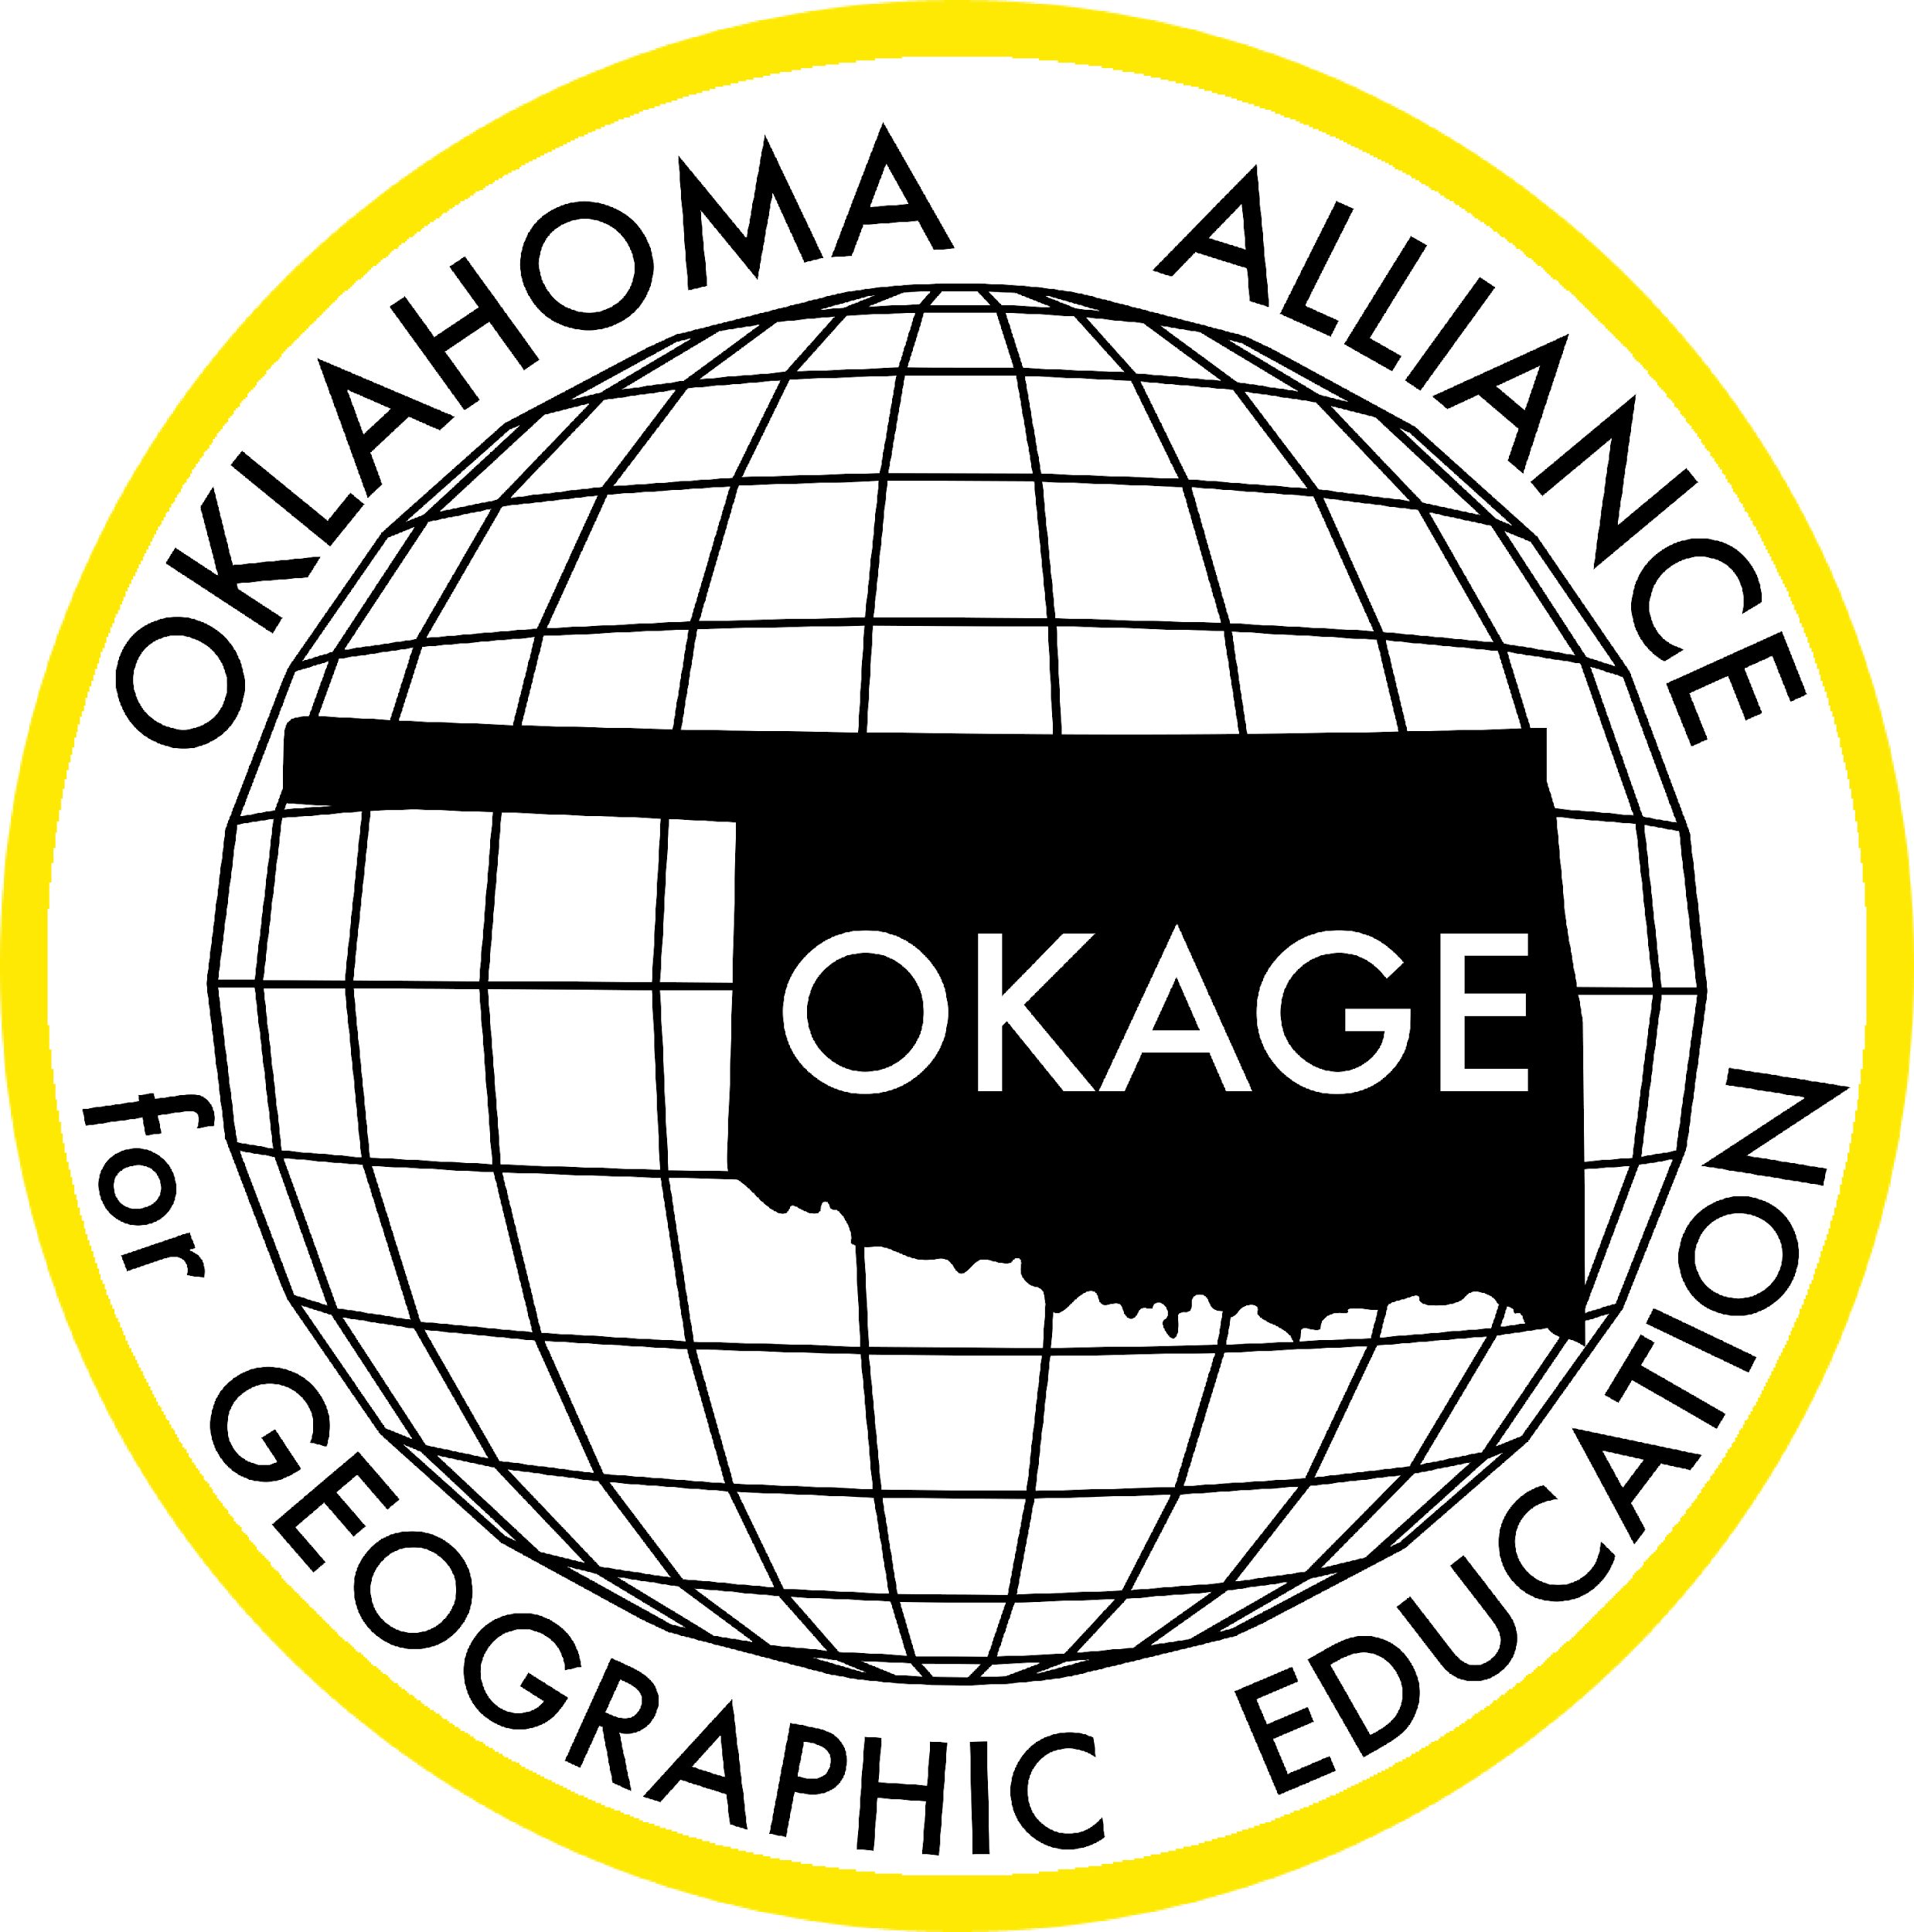
Oklahoma Alliance for Geographic Education
Teacher Training | Curriculum Development | Outreach Programs
I’m on the Top of the World Looking Down on Creation: Using the Oklahoma Giant Map to Enhance the Geo-Inquiry Process
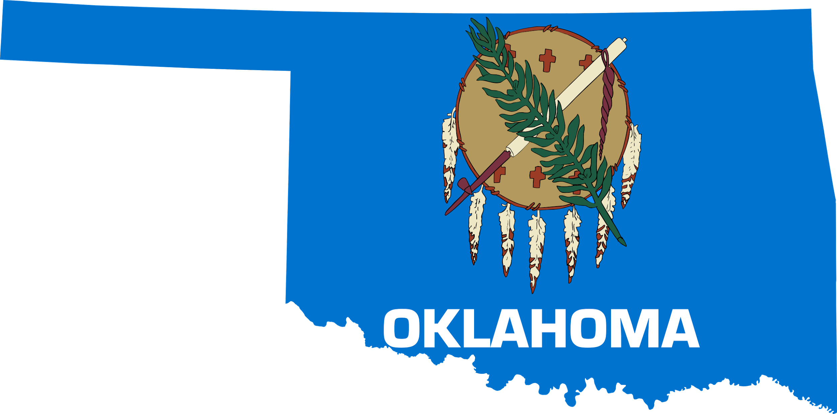

Zena Lewis
Owasso 7th Grade Center
Geography Educator, National Geographic Certified Educator, OKAGE Teacher Consultant
zena.lewis@owassops.org

100 East Boyd Street, SEC 684 | Norman, OK 73019-1018 | (405) 325-5832
www.okageweb.org | okage@ou.edu

Title: I’m on the Top of the World Looking Down on Creation: Using the Oklahoma Giant Map to Enhance the Geo-Inquiry Process

Grade Level(s): 6th & 7th Grade

Purpose/Overview:
I’m on Top of the World Looking Down on Creation is designed to allow students time to interact with the Giant Map of Oklahoma. With this hands-on learning experience, students will compare their findings to other environments at the regional or global scale. Students will learn basic cartographic concepts while using grids and latitude/longitude lines. Students will then use these map skills as they learn geographical features unique to the state of Oklahoma. This process will lead students to better understand the towns, cities, and counties represented on the map, particularly as they relate to the data and information students may collect on these places as part of a student-guided Geo-Inquiry project to understand demographic characteristics and shifts over time in Oklahoma and beyond. As students interact with key features, they will build confidence in their map skills.

National Geography Standards from Geography for Life
Geographic Elements & Standards:
National Geography Standards
Places & Regions: Standard 4: The Physical and Human Characteristics of Places
Places & Regions: Standard 6: How culture and experience influence people's perception of places and regions.
Human Systems: Standard 9: The characteristics, distribution, and migration of human populations on Earth's surface.
https://www.nationalgeographic.org/standards/national-geography-standards/

Oklahoma Academic Standards for Social Studies:
Oklahoma Academic Standards
6.3/7.3 The student will identify the characteristics, distribution and demographic patterns of human populations and systems [of the Western/Eastern Hemisphere]
6.4/7.4 The student will analyze the interactions of humans and their environment [in the Western/Eastern Hemisphere]
https://sde.ok.gov/sites/default/files/documents/files/Oklahoma%20Academic%20Standards%20for%20Social%20Studies%205.21.19.pdf

Geographic Themes:
Location (Oklahoma)
Place (the physical and human characteristics of Oklahoma)
Movement (how the Tulsa Race Massacre influenced the movement of people across the landscape and the subsequent impact upon demographic patterns we can observe today)
Human-Environment Interaction (how humans have modified the physical environment in Oklahoma by constructing homes, commercial property, and building the supporting infrastructure)
Region (The research and findings in this project could be applied to other states in an effort to understand how instances of violence towards minoritized populations not only impact the locations where they occurred, but also have a lasting influence upon the demographics and development of surrounding areas.)

Objectives:
1. What key topic/issue(s) is/are associated with this lesson/unit?
Define grids, perimeter, map scale, map legends, compass rose, push factors, and pull factors. Students will learn basic cartographic concepts while using grids and latitude/longitude lines to better understand the distribution of towns and cities in the state of Oklahoma. Students will use these map skills to learn about the migration of community members from the Greenwood District in Tulsa, OK after the tragic events of the Tulsa Race Massacre.
2. What should students know after this lesson/unit?
Following this lesson students will understand how to navigate map features on the Giant Map as well as other types of maps they will encounter in the future.
3. How will students apply this lesson/unit content?
Students will apply this knowledge of map skills as they study a variety of maps, e.g., Giant Maps, physical & political table maps, atlases, and digital map resources

Materials:
Giant Map of Oklahoma (National Geographic Floor Map 21’ X 15’)
The map can be reserved on the OKAGE website here: http://okageweb.org/giant-traveling-maps
Plastic links to measure (provided with Giant Map kit from OKAGE)
Computer w/ access to the internet for video presentation
Computers or tablets for students to conduct research
The list below has links to video-clips, news articles, and maps.

Digital Resources (videos, news articles, and maps):
Oklahoma Map PDF
Map of 1921 Black Wall Street (scroll to the bottom of the document)
1st Law of Geography
Past, Present, Future - Black Wall Street
City of Tulsa 1921 Investigation
Geo-Framework -Human World/Natural World

Time Frame: Three (45-minute class periods)
Day 1: interact with Giant Map of Oklahoma
Day 2: Research & Writing
Day 3: Visual Representation of Findings

Procedures: All backpacks and school supplies must be in a separate area. Secure a large area for the Giant Map to be opened and viewed by students. Students will wear clean socks as they come to the map area. Students will sit around the perimeter of the map and begin the lesson with directions for interacting with the Giant Map. Students will begin their engagement in mapping activities based on their personal experiences. Students will use plastic links to determine the miles from different points throughout Oklahoma. The rhetorical questions will serve as an introduction to the lesson.
Guided Questions:
- Stand in an area that you have visited in our state. Why is this area important to you?
- Stand in an area that you would like to visit. Why is this area important to you?
Perhaps your family lives in this area because of a parent’s job. You may have moved to get closer to your extended family.
- Measure the perimeter of the map with the plastic links. Measure the latitude and longitude lines with a specific focus on the grid lines. From the city of Tulsa, you will measure in all directions. What is the longest path to travel out of the state? What is the shortest path to travel out of the state? Why would this be important for those wishing to relocate following the events of the Tulsa Race Massacre? Give your students approximately 3-5 minutes to discuss with a partner why they chose their specific area. Additionally, allow time for students to share their findings of the perimeter and grid measurements. Today we will focus on the Oklahoma map and look at two different time periods in our state’s history.

Students will research and develop two timelines based on their findings.
Timeline #1: Pre-1921
Timeline #2: 1921 - Present day
What demographic patterns do you see in the state of Oklahoma? How did these patterns influence the state, and how do they continue to do so? How has Oklahoma’s population shifted over the years? Students will then create a visual representation of their findings. Images can be displayed as a chart, graph, or map. Students should locate pictures, maps, & images to help tell the story of Black Wall Street. Open discussion will be generated during this research process. The geographic theme of movement will be explained in all student presentations where they will share their findings on how Oklahoma’s population has changed over the years.

Students will begin by engaging in basic research: What is the history of Oklahoma before Black Wall Street was destroyed what and comprised the area? What is the general history following the events of May 31-June 1, 1921? What impacts of these events can we observe in present-day Oklahoma? How has Tulsa remembered the events of the Tulsa Race Massacre? Students may not be able to answer all of these questions prior to the hands-on excursion.

The teacher should be flexible in the time of student research. Discussion and research may vary between classes based on student discussion. Class discussions and students’ findings may alter the timeframe of the Geo-Inquiry lesson. Additional time and support may be required if any questions are prompted during the research.

Assessment Options: Utilize the presentation as an authentic assessment of learning. Students should be able to accurately describe the concepts explored while using the Giant Map. This assessment is visual, but should the teacher require, could also have an oral component.

Resources:
Oklahoma Map PDF
Map of 1921 Black Wall Street (scroll to the bottom of the document)
1st Law of Geography
Past, Present, Future - Black Wall Street
City of Tulsa 1921 Investigation
Geo-Framework -Human World/Natural World

Extension and Enrichment/Simplification:
Secure other Giant Maps from OKAGE to further explore how similar concepts can be observed around the world. All Continental Giant Maps are available to reserve and use in the classroom. Visit the OKAGE website to request a map: http://okageweb.org/giant-traveling-maps

