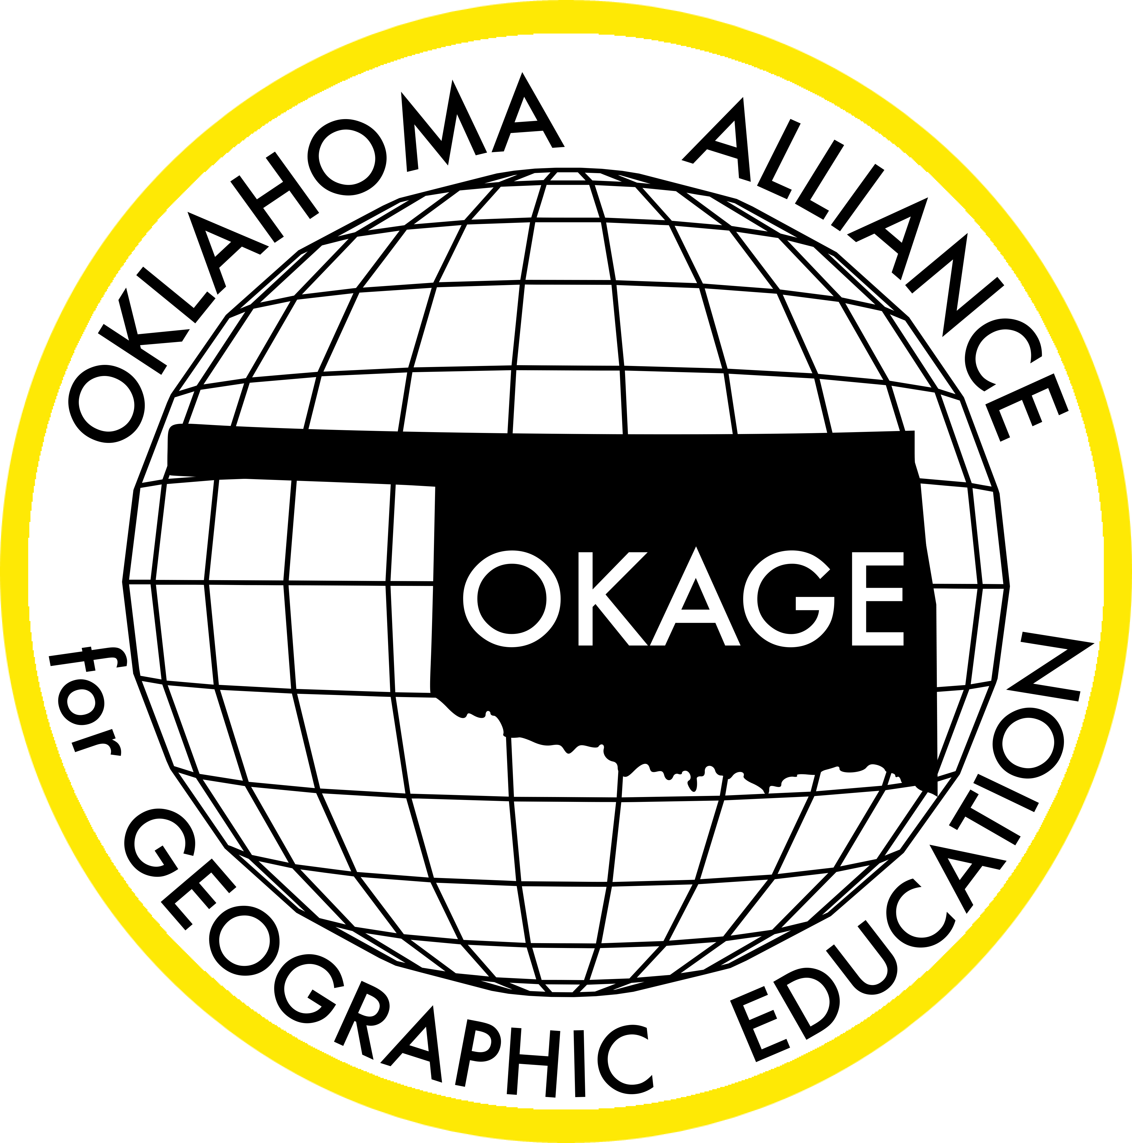
Oklahoma Alliance for Geographic Education
Teacher Training | Curriculum Development | Outreach Programs
Lights, Camera, Action!
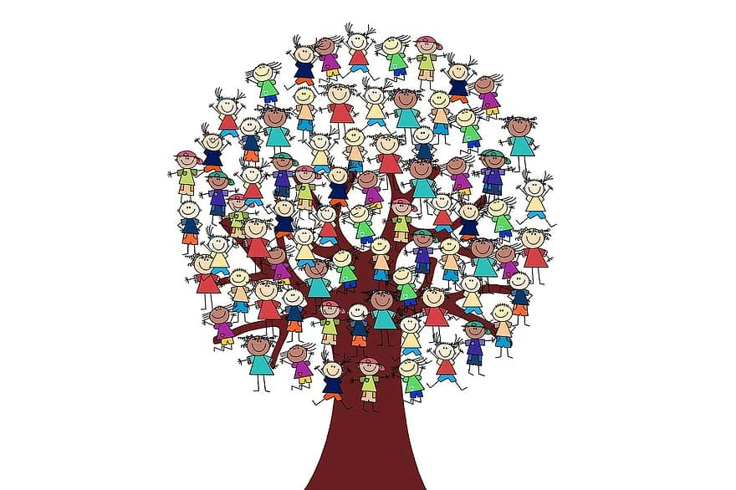

Zena Lewis

Owasso 7th Grade Center
Geography Educator, National Geographic Certified Educator, OKAGE Teacher Consultant
zena.lewis@owassops.org

100 East Boyd Street, SEC 684 | Norman, OK 73019-1018 | (405) 325-5832
www.okageweb.org | okage@ou.edu

Lights, Camera, Action!

Grade Level(s): 6th and 7th

Purpose/Overview:
The class will examine the Tulsa Race Massacre and develop a relevant Geo-Inquiry question together which is centered around the impacts of this historical event. The Geo-Inquiry process leads students to think through complexities of the world and make connections that empower them to change their communities. After a question is developed, students will be divided into teams in order to create a division of tasks - e.g., -Data Collection, Visualization, Story-Telling, etc.

National Geography Standards from Geography for Life
Geographic Elements & Standards:
https://www.nationalgeographic.org/standards/national-geography-standards/
Spatial Terms: Standard 1: How to use maps and other geographic representations, tools, and technologies to acquire, process, and report information.
Places & Regions: Standard 6: How culture and experience influence people's perception of places and regions.
Human Systems: Standard 9: The characteristics, distribution, and migration of human populations on Earth's surface.

Oklahoma Academic Standards for the Social Studies:
https://sde.ok.gov/sites/default/files/documents/files/Oklahoma%20Academic%20Standards%20for%20Social%20Studies%205.21.19.pdf
6.1/7.1 The student will analyze data from a geographic perspective using the skills and tools of geography.
6.3/7.3 The student will identify the characteristics, distribution and demographic patterns of human populations and systems [of the Western/Eastern Hemisphere]
6.4/7.4 The student will analyze the interactions of humans and their environment [in the Western/Eastern Hemisphere].
WG 1.1: Analyze key concepts underlying the geographical perspectives of location,
space, place, scale, pattern, regionalization, and globalization.

Geographic Themes:
Location (Greenwood District - Tulsa, OK; Owasso 7th Grade Center - Owasso, OK) Place (the physical and human characteristics of the Tulsa/Owasso area)
Movement (how the Tulsa Race Massacre influenced the movement of people across the landscape and the subsequent impact upon demographic patterns we can observe today)
Human-Environment Interaction (how humans have modified the physical environment in Tulsa and Owasso by constructing homes, commercial property, and building the supporting infrastructure)
Region (the research and findings in this project could be applied to other communities surrounding the Tulsa area)

Objectives:
(Related to the standards listed above)
Each lesson plan should answer in a short narrative these questions:
- What key topic/issue(s) is/are associated with this lesson/unit?
Students will understand how historical events such as the Tulsa Race Massacre have impacted, and continue to impact, surrounding communities in terms of demographic patterns. In order to do this, students will define The Five Themes of Geography, understand the difference between each theme, and discuss the themes of Geography that can be connected to Black Wall Street & The Tulsa Race Massacre. Students will also define push and pull factors, and examine how the local, regional, and global perspectives connect with historical events. Students should be able to complete a short research presentation that will challenge the entire school population. The research presentation will include the hot-spots and the school-wide inclusion initiative.
- What should students know after this lesson/unit?
Students should be familiar with the Tulsa Race Massacre, and be able to understand that this event in conjunction with other sociopolitical forces have influenced the movement of people across the landscape of Oklahoma and beyond; students will see how this crisis led to a significant decrease in the African American population as people left the Greenwood District following this event.
- How will students apply this lesson/unit content?
Students will apply the knowledge of this lesson as they understand the importance of inclusion. They will use what they have learned in this lesson to become agents of change by developing and proposing school- or community-level initiatives which aim to improve upon inclusivity toward their peers.

Materials:
Opal’s Greenwood Oasis by Najah-Amatullah Hylton and Quraysh Ali Lansana (Picture Book used to introduce the topic of the Tulsa Race Massacre)
Tulsa Burning by Anna Myers (Chapter Book to read aloud as an extension activity)
Flipgrid (Students respond to read alouds and comment on other students’ Flipgrids)
Maps of your school (to use for student-created “Hot Spots”; students will develop a map of their school as they experience it on a daily basis. As they create their maps, have them think about where students are congregating in common areas. How are these student groups alike or different? If you were a new student to the district, how would you navigate common areas of the school? Would you be comfortable with approaching a certain group of students - why or why not?)
Geo-Inquiry Process- Example
Geo Inquiry Resources/ National Geographic
Geo -Inquiry Overview- Deep Dive
Think Global to Local
The Five Themes of Geography

Time Frame: 5-7 class periods

Procedures:
During this Geo-Inquiry Process students will do the following:

- Ask a Geo-Inquiry question
- Collect data
- Visualize and organize data
- Create stories using data
- Act by sharing stories and implementing solutions

After reading Opal’s Greenwood Oasis use the following questions to spark discussions.

- Do you have a friend who is a different race than you?
- When you look at your cafeteria, what are the ways in which students group themselves?
- Explain why you think that happens.
- What can we do about it?

Based on information students have learned through videos, reading aloud, and personal research, create a plan on how your school community can be more inclusive to others. Students will develop maps of “hot spot” areas that can positively create an inclusive community. Brainstorm strategies that the entire school can use to promote inclusion. The following strategies are starting points for the brainstorming activity.

STRATEGIES OF INCLUSION:
- "Lunch Bunches" centered around common interests to help alleviate the lunchroom anxiety of where to sit, particularly for new students. Green flags are placed on tables offering seats to students that need a place. Red flags are areas where students prefer to be left alone.
- Create one or more bulletin boards in common, high traffic spaces featuring photos, artwork, and/or announcements which highlight the unique and diverse experiences of students at your school.
- "New Student Spotlight" in school news outlets - (newspaper/newscast/newsletter/bulletin boards). Feature segments of new students. Where are you from? What are your favorite types of music, movies, sports teams, places, etc.?
- Create maps of hotspots that student leaders can use to support all students (e.g., cafeteria, gym, courtyard area, etc.). Focus on high traffic areas where students may feel isolated. Empower and encourage trusted student leaders (e.g., National Junior Honor Society members, Mentors that work with exceptional students) to reach out to new students or those who appear isolated and include them in ongoing activities and conversations. Suggest they use the FORD (Family, Occupation, Recreation, Dreams) model to break the ice with students they don’t know very well. With this model, students can ask questions like, “Do you have any siblings or pets? What do you like to do for fun after school? What’s your favorite class? Where would you want to go to college? What would you like to study? What would be your dream vacation or your dream job?” etc.
- Connect student mentors with new students that arrive throughout the year. Mentors will introduce new students to the procedures of the school. Mentors will walk new students through their class schedule on their first day of class and invite them to lunch.

Plan your excursion to Tulsa Black Wall Street & John Hope Franklin Center

Students will begin by engaging in short, independent, pre-trip research time to identify locations of the Greenwood Cultural Center and John Hope Franklin Center. Students should seek to answer key questions like: What was the significance of Black Wall Street? What are some of the personal stories that can be found about people that lived in this area at this time in history? How did Black Wall Street change because of the events in this time period? What impact did these events have on other parts of the region as well as the United States? Students may not be able to answer all of these questions prior to the virtual reality or in-person tour of the Greenwood District.

The teacher should allow for approximately one half to a full class for this pre-trip research and follow up with a class discussion of the information students gathered and if any additional questions were prompted during the research. Maps were provided by the John Hope Franklin Center to understand the area before our virtual field trip.

Attend the virtual field trip or plan an in-person visit to John Hope Franklin Center.
After returning to the class, students will begin their Geo-Inquiry Process based on their student-developed question.

Together the class will develop a Geo-Inquiry question. The Geo-Inquiry process leads students to think through complexities of the world and make connections that change their communities. After a question is developed, students will be divided into teams in order to create a division of tasks - e.g., -Data Collection, Visualization, Story-Telling, etc.

Provide anchor charts & sticky notes for collaboration and discussion.
After showing the video linked below, students will collaborate on different areas within their school community that need attention then will propose and implement actions.
Geo-Inquiry Process- Example

Assessment Options:
Utilize the presentation as an authentic assessment of learning. Students should be able to accurately describe the concepts of the history of Black Wall Street, and the locations of all events. Students will use desk maps as well as the Oklahoma Giant Map to showcase their understanding of the spatial significance and implications of this event. An informal teacher observation and student presentation will serve as a teacher assessment. Students provide oral and written commentary of the new information they have learned. The Geo-Inquiry Process conclusion will be summarized in a video presentation. Although the final assessment is a media presentation, the teacher could modify the requirements to include a written and/or oral component.

Resources:
Geo-Inquiry Process- Example
Geo Inquiry Resources/ National Geographic
Geo -Inquiry Overview- Deep Dive
Think Global to Local
Maps (provided by the John Hope Franklin Center for Reconciliation or OKAGE)

Extension and Enrichment/Simplification:
1- Challenge other schools in your district to start a “Lights, Camera, Action!” initiative in their schools. Allow students to choose how to deliver the portfolio (slides, presentation, website, etc.)
2 - Hold a school event - Share the initiative in a school newspaper, school newscast/announcements, and/or district school board meeting to get the word out about your experience.
3 - Go and do- Visit the Black Wall Street & John Hopkins Center, Greenwood Cultural Center, keep learning or try to implement your solutions.

Connections (optional): Include Oklahoma Academic Standards for other disciplines/subjects that are met by your lesson/unit.
https://sde.ok.gov/oklahoma-academic-standards

