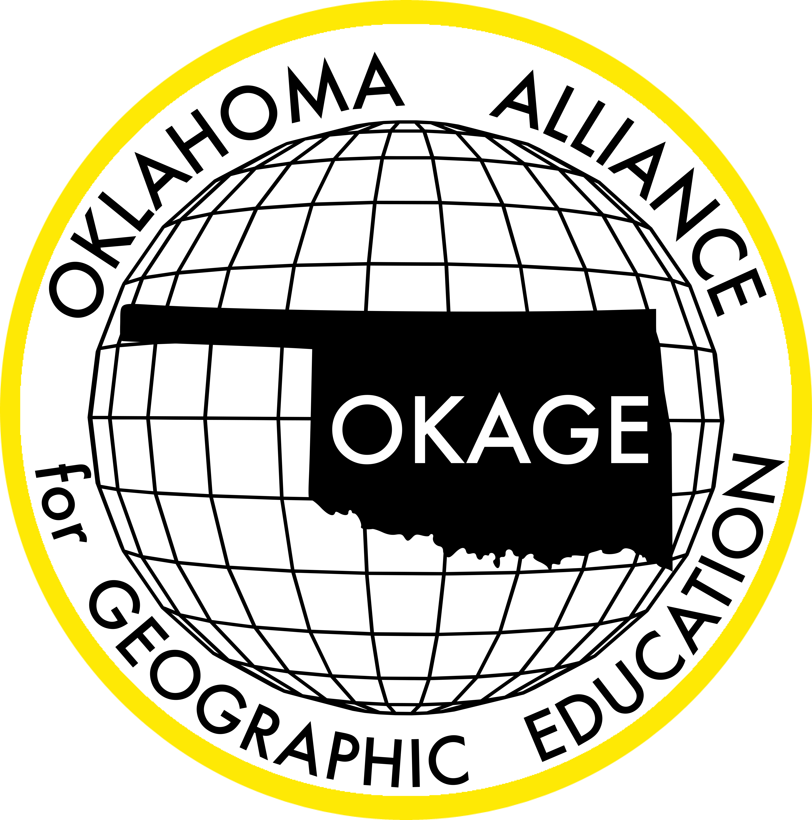
Oklahoma Alliance for Geographic Education
Teacher Training | Curriculum Development | Outreach Programs
How has COVID-19 Impacted National Parks in the United States?
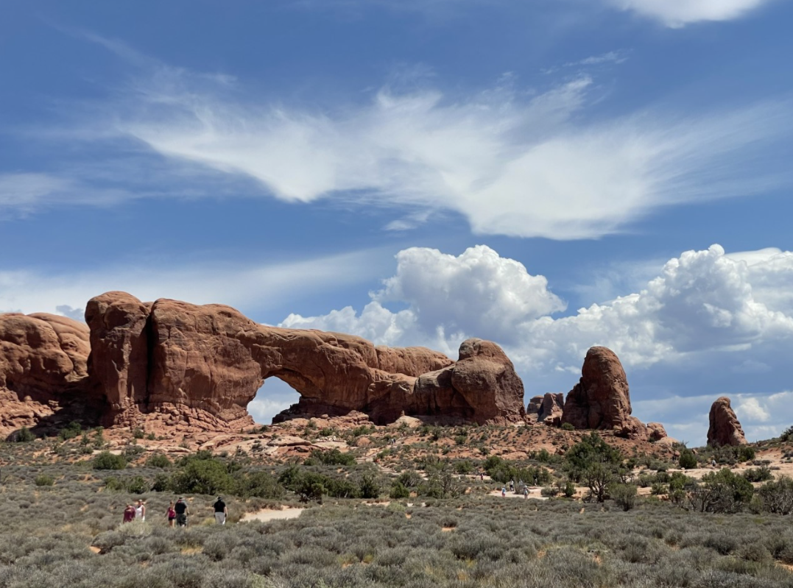

Naomi Mayer

OKAGE Teacher Consultant
Hooker Junior High
nmayer@hookerpublicschools.net

100 East Boyd Street, SEC 684 | Norman, OK 73019-1018 | (405) 325-5832
www.okageweb.org | okage@ou.edu

Lesson Title: How has COVID-19 Impacted National Parks in the United States?

Grade Level: 6th & 7th

Purpose/Overview:
Students will investigate the impacts COVID-19 has had upon public lands with a particular focus on national parks in the United States. In order to examine these impacts, students will collect data on COVID-19 cases and national park visitation around the US. The Giant Map of North America will be used to illustrate how national park visitation has changed in specific locations since the onset of the COVID-19 pandemic and how this has influenced current park management practices and policies.

National Geography Standards from Geography for Life
Geographic Elements & Standards:
https://www.nationalgeographic.org/standards/national-geography-standards/
The World in Spatial Terms - Standard 1: How to use maps and other geographic representations, geospatial technologies, and spatial thinking to understand and communicate information
Places and Regions - Standard 4: The physical and human characteristics of places
Environment and Society – Standard 14: How human actions modify the physical environment
The Uses of Geography – Standard 18: How to apply geography to interpret the present and plan for the future

Oklahoma Academic Standards for the Social Studies:
https://sde.ok.gov/sites/default/files/documents/files/Oklahoma%20Academic%20Standards%20for%20Social%20Studies%205.21.19.pdf
7.1 The student will analyze data from a geographic perspective using the skills and tools of geography
7.1.4 Integrate visual information and apply the skill of mental mapping of the political and physical features of Earth’s surface in order to organize information about people, places, and environments.
7.1.6 Describe and analyze the role of geographic factors on current events and issues.
6.4.5/7.4.5 Summarize the role of ecotourism in creating environmental awareness of resources, climate, cultures, and wildlife [in the Western/Eastern Hemisphere].

Geographic Themes:
Choose all that apply for your lesson’s focus: Location, Place, Movement, Human-Environment Interaction, and/or Region.
Location – Where are national parks located? How do these locations compare and contrast? Do you notice any spatial pattern(s) in the distribution of national parks across the United States?
Place – The physical and human characteristics of national parks and their surrounding communities
Movement – The movement of people across the landscape to visit national parks in response to COVID-19 restrictions
Human-Environment Interaction – How changes in national park visitation have impacted the environments in which they are located (e.g., increased foot and vehicular traffic, impacts of noise and light pollution on wildlife, tourist safety issues, changes in tax revenue for local communities, changes in development patterns around national parks, increased pollution on trails and in waterways, degradation or improper use of hiking trails, sanitation issues, potential conflict between tourists and locals, etc.)

Objectives:
(Related to the standards listed above)
Each lesson plan should answer in a short narrative these questions:
1. What key topic/issue(s) is/are associated with this lesson/unit? Students will investigate how COVID-19 has impacted public lands in terms of visitation, and how changes in visitation can affect the land, wildlife, and local economies where national parks are located. Students will also research current management practices and any applicable restrictions put in place by the National Parks Service to mitigate the spread of COVID-19 while minimizing negative impacts upon the parks.
2. What should students know after this lesson/unit? Students should have an understanding of how national parks are managing changes in visitation through the COVID-19 pandemic and how the pandemic might impact management practices in the future.
3. How will students apply this lesson/unit content? After conducting their research, students will use the Giant Map of North America to visualize and interpret their results. Each pair of students will share their research with the class and the entire group will have the opportunity to examine the spatial distribution of the national parks researched by the class and discuss any patterns they notice.

Materials: List all tangible items needed for the lesson (e.g., handouts, atlases, calculators, colored pencils, construction paper, PowerPoint, computer/LCD projector).

- Access to devices (with internet) for student research (contact okage@ou.edu if you need computers for your students to use)
- North America Giant Map (provided by OKAGE; contact okage@ou.edu to make a reservation)
- A large space for the Giant Map – the North America Giant Map measures 20 by 26 feet.
- Materials or props for the students to mark locations on their map (included with North America Giant Map kit)

Time Frame: 3-4 class periods. The suggested timing is as follows:
Class period 1 – Introduce the topic and conduct the initial brainstorming session. Students begin conducting research as time allows.
Class period 2 – Students research their national park of choice and collect COVID-19 data in that area
Class period 3 – Student research should be complete by the beginning of this class period. They will then share their research and findings with the class using the North America Giant Map, and other students will have the opportunity to comment, ask questions, or provide feedback. As a class, students will look at the final distribution of all of the national parks that were researched by their classmates.
Class period 4 (optional extension/enrichment) – Have students plan a trip to the national park they researched. Potential items to research include, length of trip, budget, method(s) of transportation, lodging location(s), potential activities, etc.

Procedures: Identify each step/activity driving the lesson in a narrative description ("students will"..."the teacher will"): i.e., opening the lesson, developing the lesson, concluding the lesson, closure (can be a product). Provide specific documents which contain classroom-ready examples for each activity when necessary.

1. Brainstorm: Do you think COVID-19 has affected National Parks? If so, do you think it has had positive or negative effects on the park?

Have your students brainstorm how they think national parks have been affected by COVID-19. Has national park visitation increased or decreased during the COVID-19 pandemic? If visitation has increased, what effects has this had on the park? If visitation has decreased, how might that impact the surrounding communities? This exercise should be conducted as a class discussion so the students can hear ideas from one another. The teacher can write which effects the students think are happening to the national parks on the board in front of the class.

2. Have students pair up and choose a national park.

Have students pair up and choose a national park to research. They will then use their classroom or lab computers to look up information about the park. They will first look up how many visitors the park can typically accommodate during a normal year and historic visitation data. Students will then research if the park that they chose has implemented any COVID-19 restrictions regarding the number of people that are allowed in the park or allowed in certain areas of the park at any given time.

3. Student pairs will examine how COVID-19 has impacted the park that they have chosen.

Students will look up more information about the national park that they chose and find information on which COVID-19 restrictions their national park has put in place. They can begin by using the website NPS Public Health Update (U.S. National Park Service). This website will give them information on current COVID-19 restrictions and it will also allow them to search for their national park. After they have researched this information, they will share their results with the class. As a class, students will compare and contrast the visitation trends and COVID-19 restrictions of the national parks they have researched.

4. Giant Map of North America
Each student pair will make an object that represents their national park. They will then put what they have created on the North America Giant Map. It is recommended that this activity take place in your school’s gym so after they have marked their national park on the map, the entire class can go into the stands to see the overall spatial distribution of the national parks they have researched. This will also give them a chance to see if any other spatial patterns have emerged such as differing COVID-19 restrictions between regions.

Assessment Options: Summarize what your suggested assessment will be. Refer back to objectives above: how will the teacher know that students have learned the intended objectives?
Application assessment
Performance-based assessment
Authentic assessment
Rubric assessment
Assessment can be individual, group, project, product, long-term, short-term, student-directed, student-produced, written, oral, visual, field-based, research-based, etc.

The teacher will use the short research presentations during the Giant Map exercise and will review the students’ research materials as authentic assessments for this unit. The teacher should consider the credibility of sources used for student research, the clarity and organization of the information presented, the students’ demonstrated understanding of the content in their presentation, and the effort put forth by each student.

Resources:

https://www.nps.gov/aboutus/news/public-health-update.htm - Use this link as a starting point for your students’ national park research.

https://covid.cdc.gov/covid-data-tracker/#datatracker-home - This is where you and your students can explore COVID-19 data. A good way to visualize the data is by county which can be found by going to “Your Community”, then selecting “County View”. Contact okage@ou.edu if you need help finding specific data.

Extension and Enrichment/Simplification: Describe how a teacher could adapt this lesson: to higher/lower grades, gifted or special needs students, and/or to reduce the amount of time needed to present the lesson.

As an enrichment activity, have students plan a trip to the national park they researched as if they are leaving from their hometown. They will need to determine a budget and the amount of time required for their trip, develop a sample itinerary, and plan their lodging.

Connections (optional): Include Oklahoma Academic Standards for other disciplines/subjects that are met by your lesson/unit.
https://sde.ok.gov/oklahoma-academic-standards

