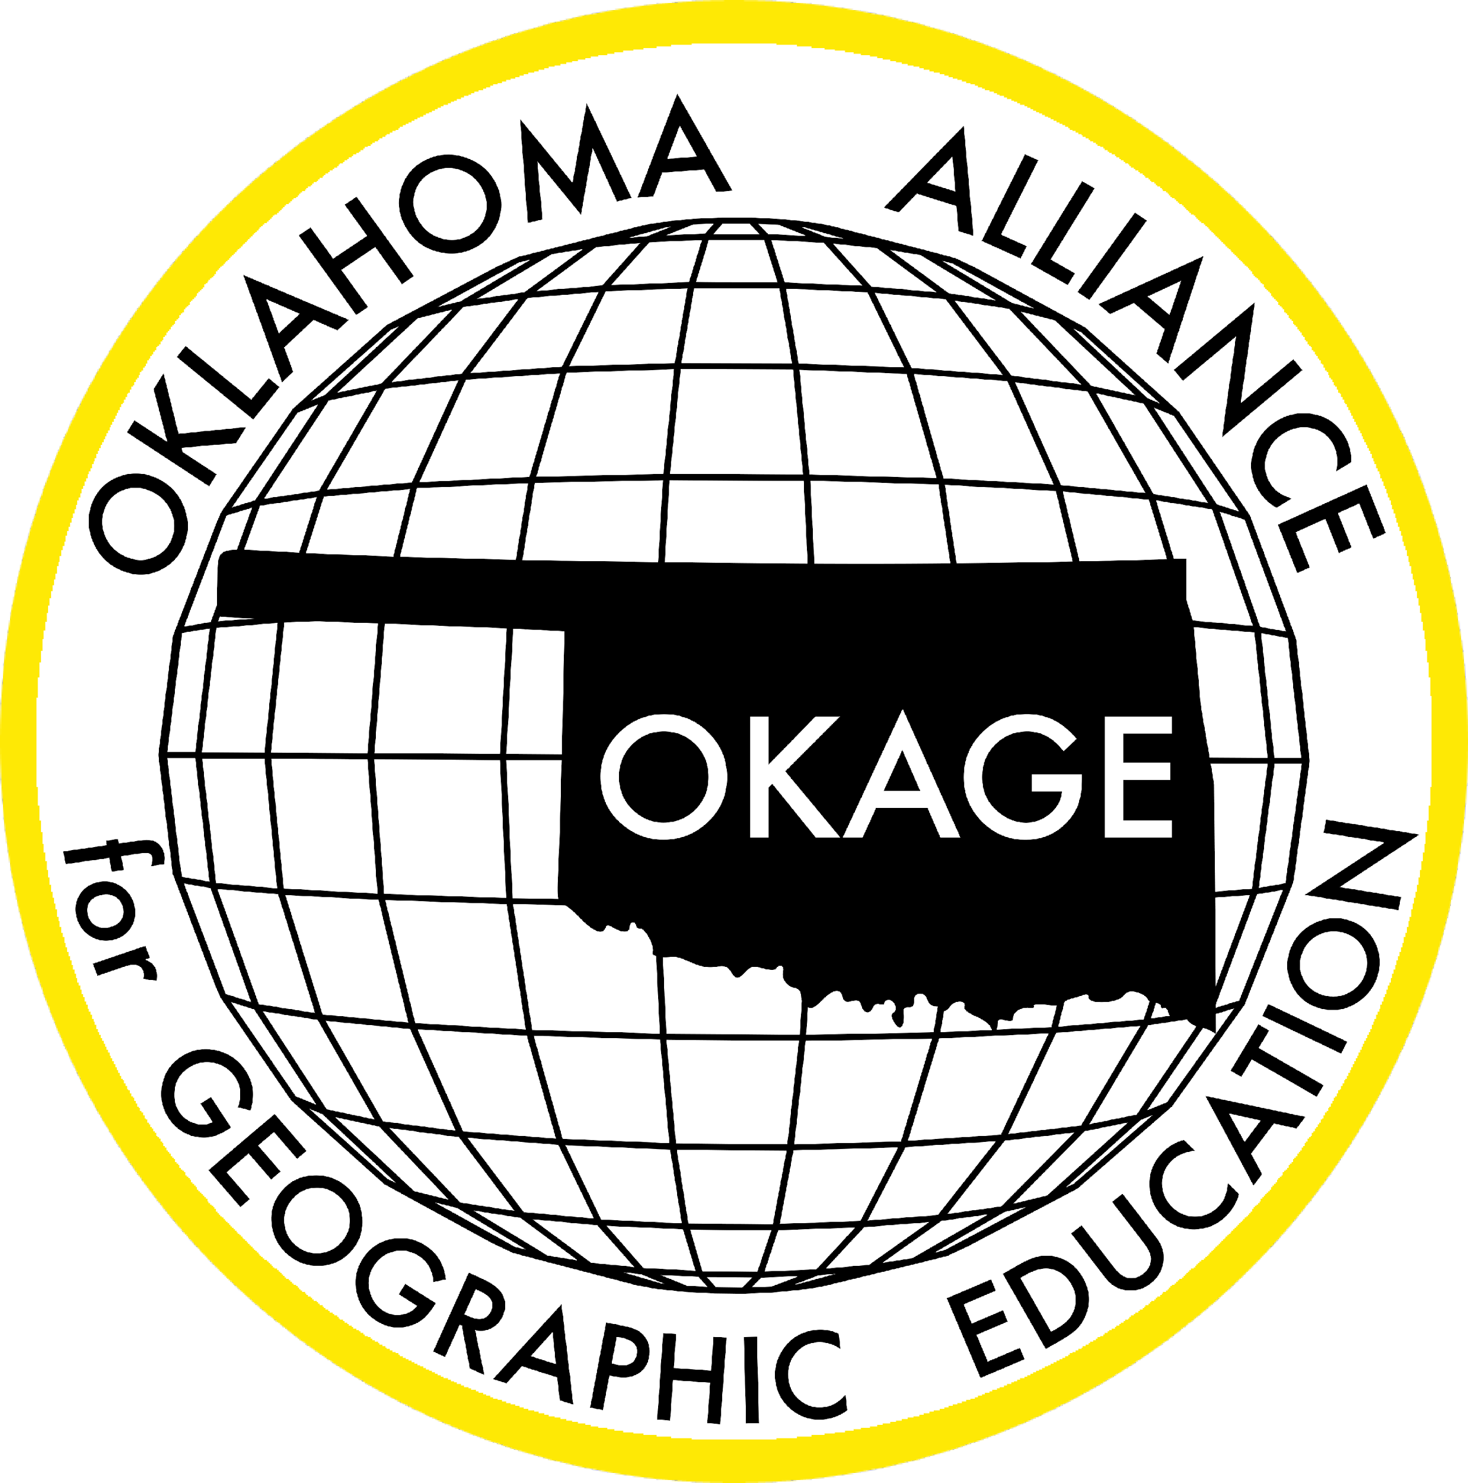
Oklahoma Alliance for Geographic Education
Teacher Training | Curriculum Development | Outreach Programs
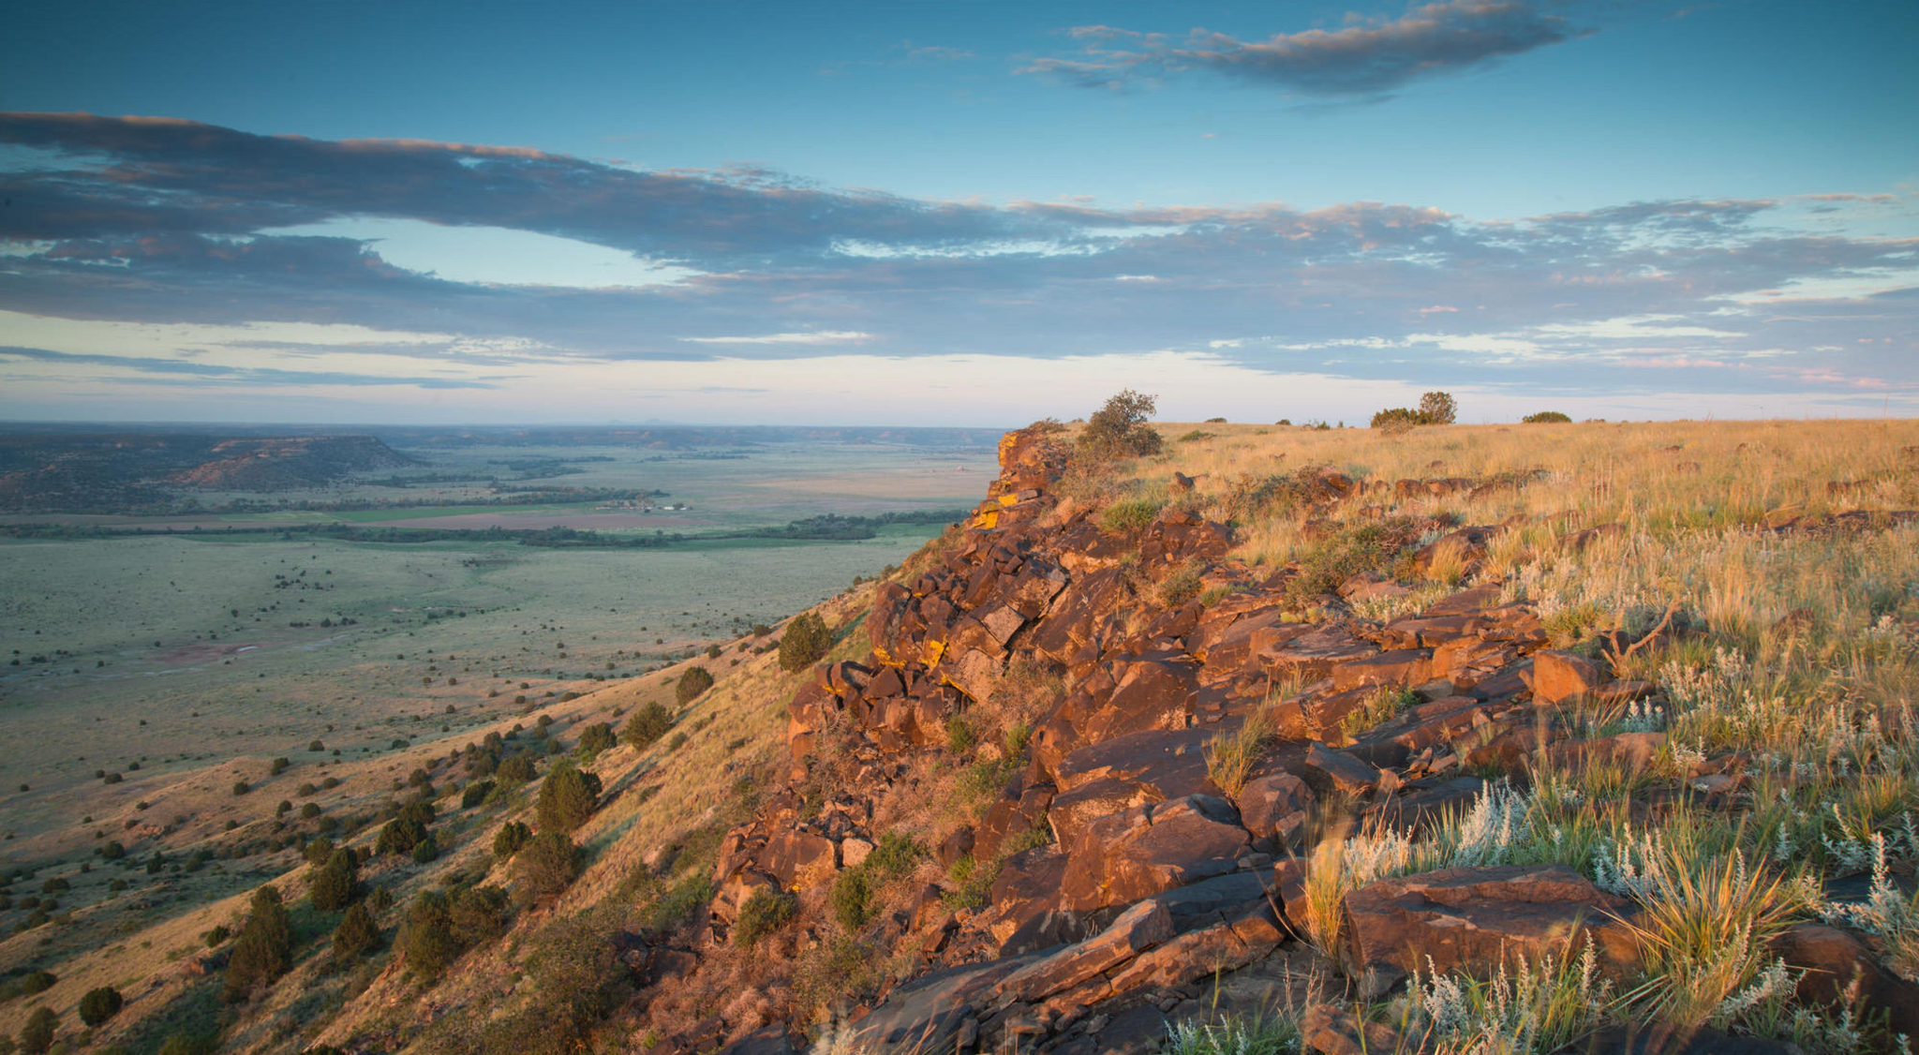
Using the Geo-Inquiry Process to Explore and Understand Black Mesa State Park

Naomi Mayer
Hooker JR/High School
7th grade Geography Teacher
nmayer@hookerpublicschools.net

100 East Boyd Street, SEC 684 | Norman, OK 73019-1018 | (405) 325-5832
www.okageweb.org | okage@ou.edu

Lesson Title: Black Mesa Geo-Inquiry Project

Grade Level: 6th - 7th grade

Purpose/Overview:
For this lesson students will look at how COVID-19 has affected Black Mesa State Park. They will then learn how to use the National Geographic Geo-Inquiry process to explore the issues related to Black Mesa through a geographic lens. The students will then develop their own Geo-Inquiry questions so they can research how COVID-19 has affected this state park. After they have gathered this information they will then go to Black Mesa State Park and meet with the Park Manager so students may ask the questions that they have formulated and for the Park Manager to show the students the physical effects that COVID-19 has had on Black Mesa State Park due to the influx of visitors. Upon completion of the in-class and field research components, students will present their findings to classmates and/or publicize their results to be accessed by stakeholders.

National Geography Standards from Geography for Life
Geographic Elements & Standards:
https://www.nationalgeographic.org/standards/national-geography-standards/
Standard 1 - How to use maps and other geographic representations, geospatial technologies and spatial thinking to understand and communicate information
Standard 14 - How human actions modify the physical environment
Standard 15 - How physical systems affect human systems
Standard 16 - The changes that occur in the meaning, use, distribution, and importance of resources

Oklahoma Academic Standards for the Social Studies:
https://sde.ok.gov/sites/default/files/documents/files/Oklahoma%20Academic%20Standards%20for%20Social%20Studies%205.21.19.pdf
Standard 6.4.6 - Describe the role of citizens as responsible stewards of natural resources and the environment
Standard 7.3.6 - Describe the distribution of resources and evaluate how the three levels of economic activities (primary, secondary, tertiary) contribute to the development of a country or region.
Standard 7.4.6 - Describe the role of citizens as responsible stewards of natural resources and the environment

Geographic Themes:
Movement - In this lesson students will learn about how the visitation patterns in Black Mesa State Park have changed since the onset of COVID-19.
Human-Environment Interaction - Students will learn about how the changes in visitation at Black Mesa State Park have impacted the land and wildlife.
Objectives:
- Students will be able to examine the impacts of COVID-19 upon Black Mesa State Park. The students will conduct their own research to see what effects the Covid-19 pandemic has had and will evaluate these effects to see if they have been negative or positive for the State Park.
- After this lesson the students will know what the impacts of COVID-19 have been on Black Mesa.
- The students can apply what they have found about the impacts of COVID-19 on Black Mesa and be able to research some ways to help lessen any negative impacts that have happened to the environment due to the changes in visitation that occurred because of the COVID-19 pandemic.

Materials:
The students will have a folder and a notebook in order to write down questions they would like to direct to the Park Manager along with any information they gathered during the research process prior to going on the field trip. Students should also bring their notebooks on the field trip to record notes and observations.

Time Frame:
Five after school days, one hour each, or five class periods.

Procedures:
The teacher will hand each student the Black Mesa Geo-Inquiry Guideline. The teacher will then go over this guideline with the students. As the teacher is going over this guideline they will ask the students to start making notes of questions they may have on the guideline. The students will then begin forming a plan of how they are going to gather the data and research the questions that they have formed while going over the Geo-Inquiry guideline. As the students research their questions, the teacher will be going around to check that they are on the right path. If the teacher notices that they are needing assistance, the teacher will guide them to additional resources. During the last ten minutes of class, the teacher will then get the whole group of students back together and they will look at the data they have collected and work together to see if more research is needed or if the information that they have collected is sufficient.

Assessment Options:
The teacher will assess the students together as a group. The teacher will do this by checking the students’ progress at the end of each after school meeting or class period. They will do this by observing what the starting points of the students' research questions for that day were and at the end of each period assess the group’s progress for the day. The teacher will then observe the degree to which the students are engaged in the field experience by interacting with the Park Manager, taking notes, and recording observations about the current state of the park and how to help the park in the future if another pandemic should happen, or if there is an influx of visitors for any other reasons.

Resources:
Black Mesa State Park & Nature Preserve | TravelOK.com - Oklahoma's Official Travel & Tourism Site
Black Mesa Preserve (nature.org)
Conduct personal interviews with the Park Manager and collect information on Black Mesa during the field experience

Extension and Enrichment/Simplification:
To adapt this lesson to lower grades, reduce the amount of time required, or to accommodate for special needs, give the students the research questions that you want them to explore and also give them a list of websites that they could use to gather information. For higher grades or gifted students, the teacher could give them a basic overview of the Geo-Inquiry process and have them complete a Geo-Inquiry project outline before beginning their research on Black Mesa State Park and the impacts of COVID-19.

